Task | Story Points | Delivered by | Estimation | Remarks
Database | 3 | Zorrilla | 2 days | 0%
Account - CRUD | 5 | Zorrilla | 2 days | 0%
Account - UI | 3 | Gozar | 1 day | Done
Document List Interface | 3 | Limon | 2 days | Done
Routing of Documents | 8 | Arboleda | 3 days | 0%
Document Tracking | 8 | Arboleda | 2 days | 0%
SMS Notification | 5 | Zorrilla | 2 days | 0%
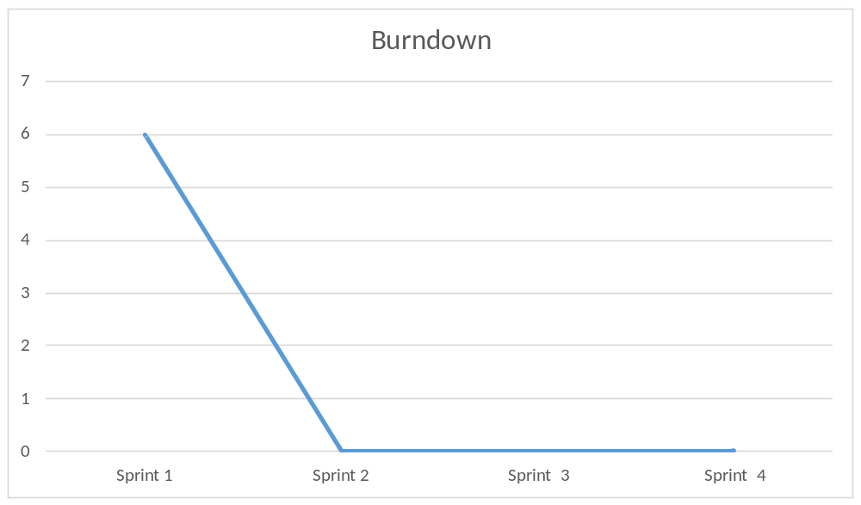

What went well?
The interface
What went wrong?
Zorrilla and Arboleda did nothing
What to improve
Everything

